Name _____________________ Constructions Guide

Directions: Be sure that you are using a compass and a straightedge to complete all constructions.

1) Go to http://mathopenref.com/tocs/constructionstoc.html

2) Click on each construction tutorial (listed at the bottom of this page). Click on the “NEXT” button to watch the tutorial. These are the constructions you need to know for the constructions quiz.

Question # | Construction Tutorial Name
1 | Copy a line segment
2 | Copy an angle
3 | Bisect an angle
4 | Perpendicular to a line at a point on the line
5 | Perpendicular bisector of a line segment
6 | Perpendicular to a line from an external point
7 | A parallel line through a point (angle copy method)
8 | Hexagon Inscribed in a Circle
9 | Inscribed Equilateral Triangle (same as hexagon but connect every other point)
10 | Square Inscribed in a Circle

1) Copy the line segment.

2) Use segment addition postulate to create one long, copied segment.

3) Copy the angle. 4) Bisect the angle.

5) Copy $∠UET$.
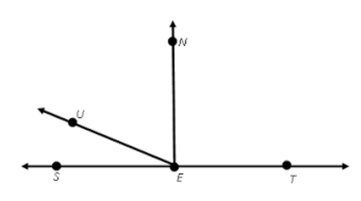

6) Construct a line perpendicular to the given line through the point.

7) Construct the perpendicular bisector of $\overline{AB}$.

8) Construct a perpendicular line to the segment through the given point.

9) Construct a parallel line through the given point.

10) Construct an inscribed equilateral triangle with radius $\overline{AB}$.

11) Construct an inscribed hexagon with radius $\overline{BC}$.

12. Construct an inscribed square with diameter $\overline{AC}$.

