3.4 Introduction to Triangles Part II Geometry
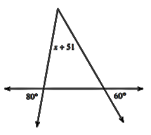
Directions: Solve for x. Then find each interior angle measure.
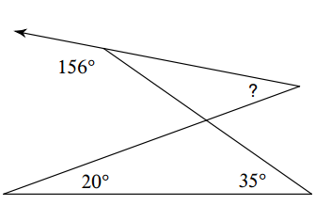
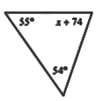
1) 2)

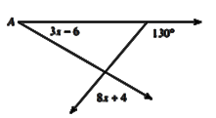
Directions: Find the measure of angle A.
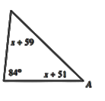
3) 4)

Directions: The variable expressions represent the angle measures of a triangle. Find the measure of each angle. Then classify the triangle by its angles.
5) m∠C = xᴼ 6) m∠W =xᴼ 7) m∠D = (x – 15)ᴼ
m∠A = 2xᴼ m∠H = 7xᴼ m∠U = (2x – 165)ᴼ
m∠T = (2x + 15)ᴼ m∠Y = xᴼ m∠H = 90ᴼ

Directions: Determine if the three numbers can make the sides of a triangle.
8) 7, 5, 4 9) 3, 6, 2 10) 5, 2, 4 11) 8, 2, 8

Directions: Two sides of a triangle have the following measures. Find the range of possible measures for the third side.
12) 9, 5 13) 5, 8 14) 6, 10 15) 6, 9

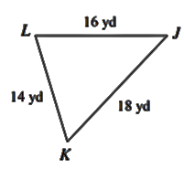
Directions: Write the angles of the triangles in order from least to greatest.
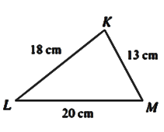
16) 17) 18) In ∆MOP,
MO = 15
OP = 25
MP = 13

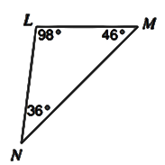
Directions: Write the sides of the triangles in order from least to greatest.
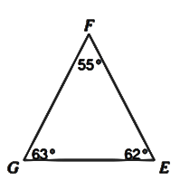
19) 20) 21) In ∆TOP,
m∠T = 50ᴼ
m∠O = 48ᴼ
m∠P = 82ᴼ

